

**EXPLORE WEATHER TRENDS**

** Udacity – Data Analyst Nanodegree**

**By Nischitha K C**

**Project – 1, Explore Weather Trends,**

**Bangalore, India.**

**Overview**

In this project, I have analysed and compared the weather related data between Bangalore, India and Global temperature which is provided in the Udacity database portal.

**Goals**

1. To extract the data from database and export them as CSV file.
2. Create a chart which displays the related data.
3. Make observations, comparisons between Global and City average temperature.

**Tools Used**

1. **SQL**: To extract the data from the database.
2. **MS-EXCEL**: For calculating Moving Average and plotting the Line Graph.

**Steps**

**Step1: Extraction of Data from provided Databases.**

I have considered Bangalore city from country India to compare the temperature with Global Temperature. Provided tables are **city_list, city_data** and **global_data**.

* Check which cities are available in the Country India?

**Select * FROM city_list WHERE Country = ‘India’;**

**Output:** Displays all the city names in India.

* Retrieve only Bangalore city from table.

**Select * FROM city_data WHERE Country = ‘India’ AND City = ‘Bangalore’;**

**Output:** Displays the data related to Bangalore city which includes year and average temperature.

* Retrieve data from global_data table.

**Select * FROM global_data;**

**Output:** Displays the entire column from the table.

**NOTE: Since city_data and global_data have the same column name avg_temp, it is needed to change the column names.**

* To change the column name avg_temp to city_avg_temp in city_data table.

**Alter TABLE city_data RENAME COLUMN avg_temp to city_avg_temp;**

* To change the column name avg_temp to global_avg_temp in global_data table.

**Alter TABLE global_data RENAME COLUMN avg_temp to global_avg_temp;**

* To get the relevant data information to compare city temperature and global temperature I have joined the two table’s i. e., city_data and global_data.

**Select global_data.year, global_data.global_avg_temp, city_avg_temp FROM global_data INNER JOIN city_data ON global_data.year = city_data.year WHERE city = ‘Bangalore’;**

**Output:** Displays the temperature column from both the table along with the year.

**NOTE: Collect or download the CSV files after running each query for plotting the line chart as well as to check the MOVING AVERAGE which is described in the next step.**

**Step 2: Creating a Line Chart using Microsoft EXCEL.**

I have downloaded the CSV file related to global temperature and city temperature that is the table which includes year, global_avg_temp and city_avg_temp columns.

* **Moving Averages**

1. To explore the temperature trends, I calculated the moving average for 20 years from 1951 to 1970 to get a smooth line chart.
2. To calculate Moving Average (MA) in a EXCEL sheet formula (command) used is **fs = AVERAGE(B157:B176).**
3. Line chart for Bangalore average temperature and Global average temperature for 20 – year Moving Average is shown below.

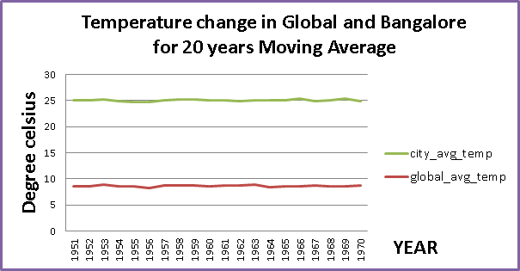

* **Observations**

1. Basically Bangalore city average temperature is more compared to Global average temperature. Bangalore city temperature is hotter than Global temperature.
2. Bangalore city temperature varies between 23.3 to 26.61 whereas Global temperature varies from 6.86 to 9.73.
3. From the above chart we can notice a constant rise and fall in the temperature in both Bangalore city temperature and Global temperature but a constant increase in the temperature is shown in the below chart.

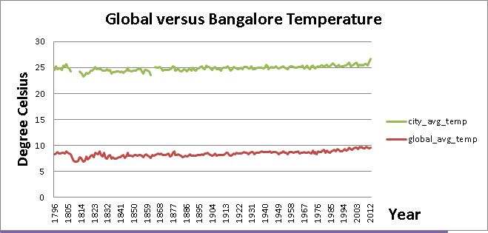

1. During early years, both Bangalore city temperature and Global temperature have similar trends and **during 1980s both are started increasing.**
2. Finally Moving Average for Bangalore city temperature is **24.85** and Moving Average for Global temperature is **8.40**.

**Conclusion**

Calculating the overall Moving Average for Bangalore city temperature and Global temperature are **24.85 and 8.40** respectively and calculating the Moving Average for both from **1951 to 1970 is 25.05 and 8.645** respectively. By analysing the above data we can come to the conclusion that “If Global Temperature raises automatically the temperature of the cities all over the globe also increases”. Therefore, finally, “**THE WORLD IS GETTING HOTTER**”.